Preliminary Tests

**Preliminary Test #1 – Which Program to use?**

I carried out this test so that I will be able to use a program which provides reliable and valid data as well as ease of access for me (the experimenter) as well as ease of access for the participants of my experiment. To find my programs I used the search engine ‘google’ and used the top 3 rated reaction time testing programs, and from that I have decided to carry out my own research into the best program to use. I wish to find out which one of the top 3 programs is in fact the best program to use to accurately measure reaction times.

The top three programs for measuring reaction times were:

1. The Human Benchmark Program (REFERENCE)
2. Sheep Dash Program (REFERENCE)
3. Traffic Light Program (REFERENCE)

For my preliminary test I used 5 participants for each program. I did this so that I could test the reliability and the validity of the program. From this I hypothesised that the program with the lowest average range would be the most desirable program; however if the programs drew in range values I would take into consideration the participants preference of the program. Below are tables showing the pros and cons for each individual program:

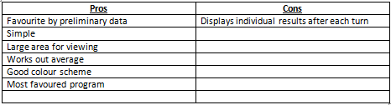Human Benchmark Program

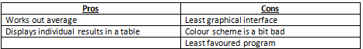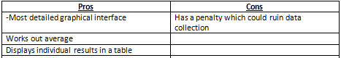Sheep Dash Program  
  
  
  
  
Traffic Light Program

From these tables without precise data you can see that the Human benchmark Program has the most pros and the least cons whereas at the other end of the spectrum the Traffic Light Program has the least pros and the most cons. I predicted from this that the Human Benchmark Program was the program that I was more likely to use, and the program that was going to get the best results.